N-M-78-F

Material and plating
Connector parts Material Plating
Center contact Brass Ag
Outer contact Brass CuSnZn
Fastener Brass Ni
Dielectric PTFE -
Gasket Silicon -

Technical Specifications
Operating Frequency Band | ≥ 3.6Ghz
Insertion Loss | ≤0.05dB
Impedance | 50 Ω
Contact resistance | Center contact≤ 1.0mΩ  Outer contact≤ 0.25mΩ
Insulation Resistance | ≥ 5000 MΩ
PIM3 | ≤-155dBc@2*20W
Return Loss (dB) | 50MHz~1000MHz: ≥ 34  1000MHz~1900MHz: ≥ 32  1900MHz~2200MHz: ≥ 32  2200MHz~2700MHz: ≥ 31
Interface | N Male
Bod Style | Straight
Peak Power in Maximum(kW) | ≥ 0.7
Mating cycles | 500
Coupling Torque | ≥30NM
Dielectric Strength | 2500 V, AC, 1Min
Operating Temperature | -40~+85 °C
Relative Humidity | 0~95 %
Application | Indoor or Outdoor (IP68)
Change of temperature | IEC 60068-2-14/GB/T 2423.22
Salt mist | IEC 60068-2-11/GB/T 2423.17
Vibration | IEC 60068-2-6/GB/T 2423.10
Shock | IEC 60068-2-27/GB/T 2423.5
Damp heat, steady state | IEC 60068-2-3/GB/T 2423.3
Protection class | IEC 60529/GB 4208
Suitable cables | 7/8’’ Feeder  applicable for Feeder: Smooth tube / smooth round cylinder, Outer Conductor / ring corrugated copper tube, Inner Conductor / 9.3 ± 5% mm diameter core conductor, Outer Conductor glass 24.9 ± 5% mm, Jacket / plastic sheath with diameter 27.9 ± 5% mm, Outer Conductor / SIN wave conductor / SIN waveform, Dielectric / Insulation between the core conductor and the sheath conductor is Polyethylene Foam
Weight(g) | ≥ 136

Drawing
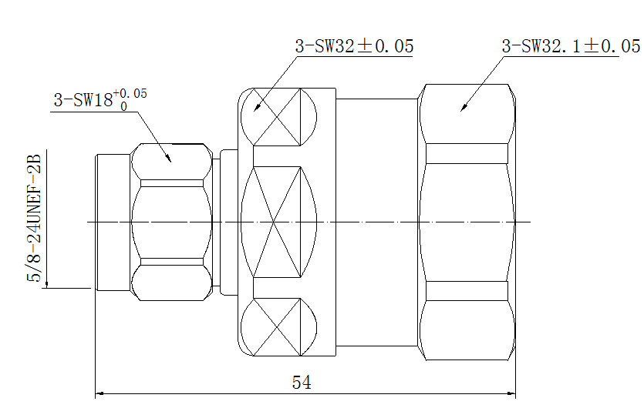

According to IEC 61169-16

